**E-BANKING SYSTEM FOR SENIOR CITIZEN**

The bank that implements a modern way of banking and will adapt itself to the rapidly changing scenario in the banking industry.It is most useful for the elderly people who struggle working with the website.This website provides necessary walkthroughs for easy access.For example, while filling the nominee field in account creation form there will be a walkthrough providing info about the nominee and reason for filling the field.This project is basically designed for the elerderly people because this gives a basic walkthrough on each and every feature in the website.This project also gives a general understanding of what online banking is all about.As senior citizens cannot go to the bank and do things physically for even a basic requirement, this website will help them do it from where they are and as not all the elderly people have knowledge about e-banking.

SCREENSHOTS:

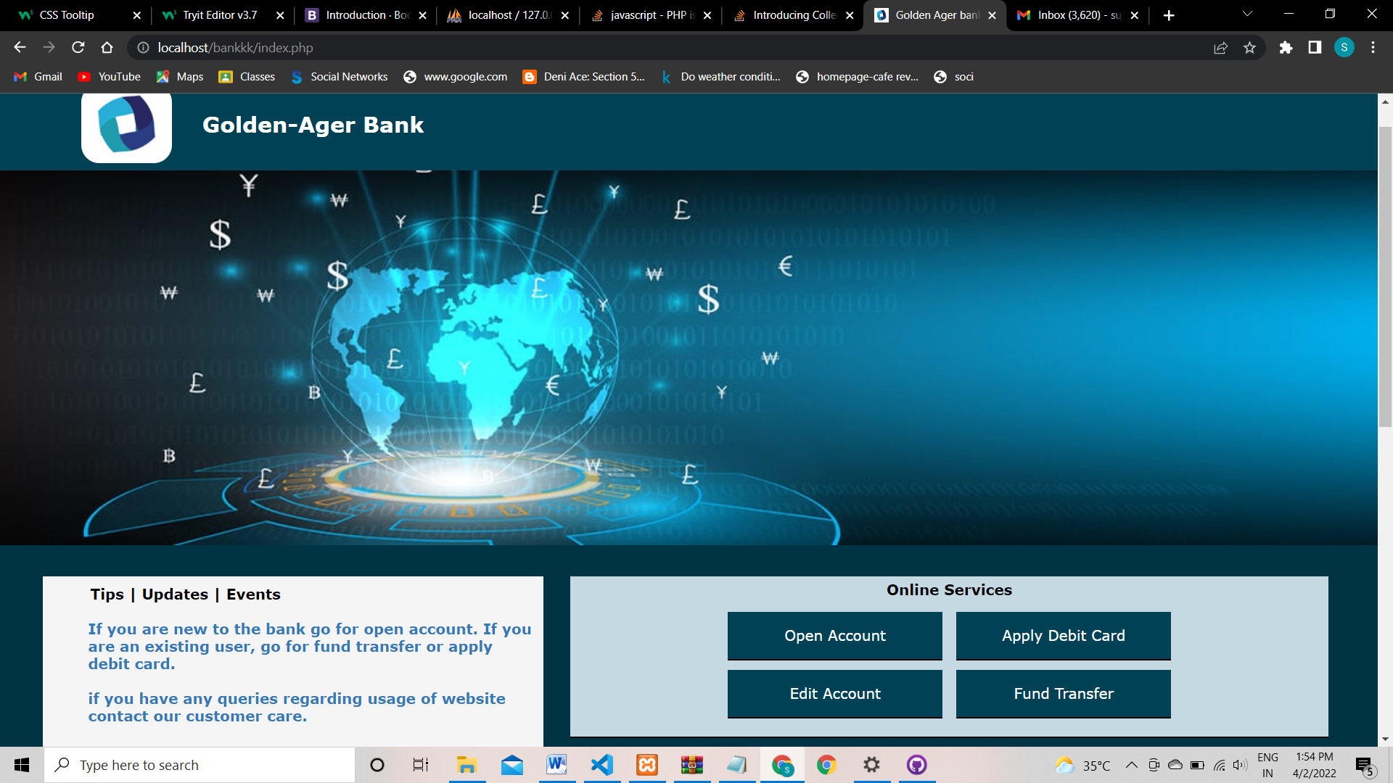

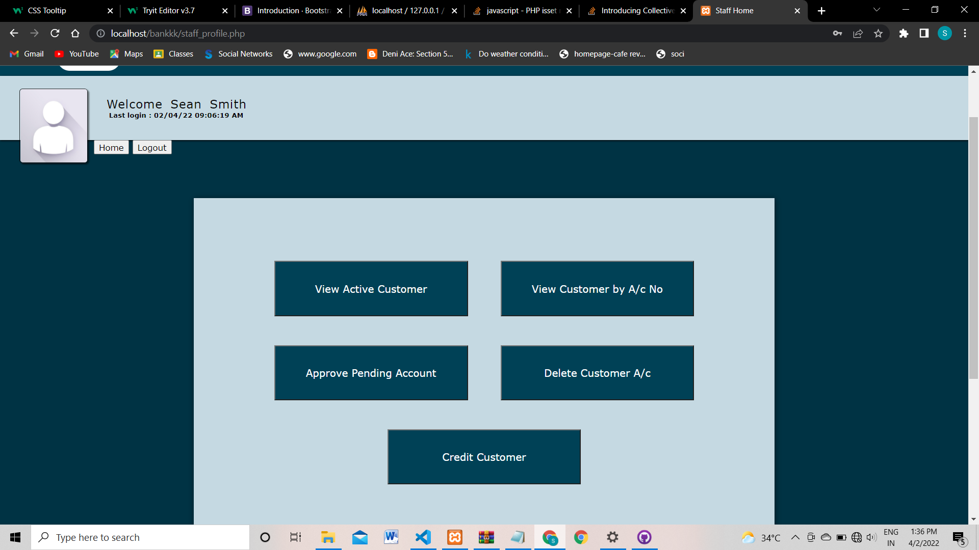

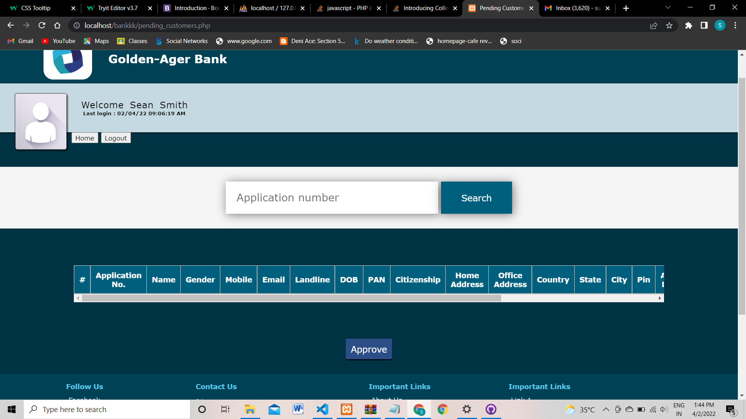

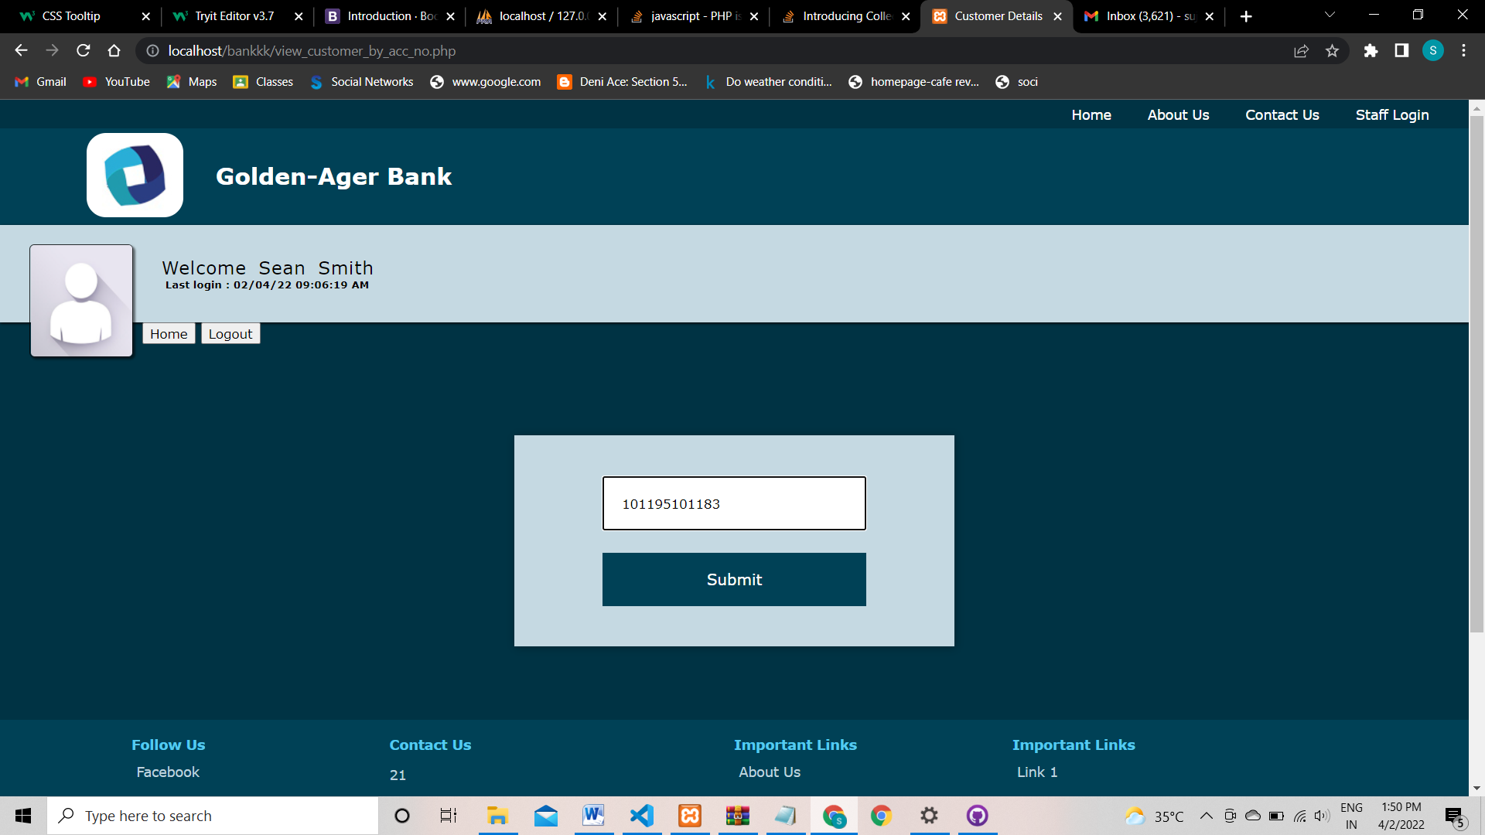

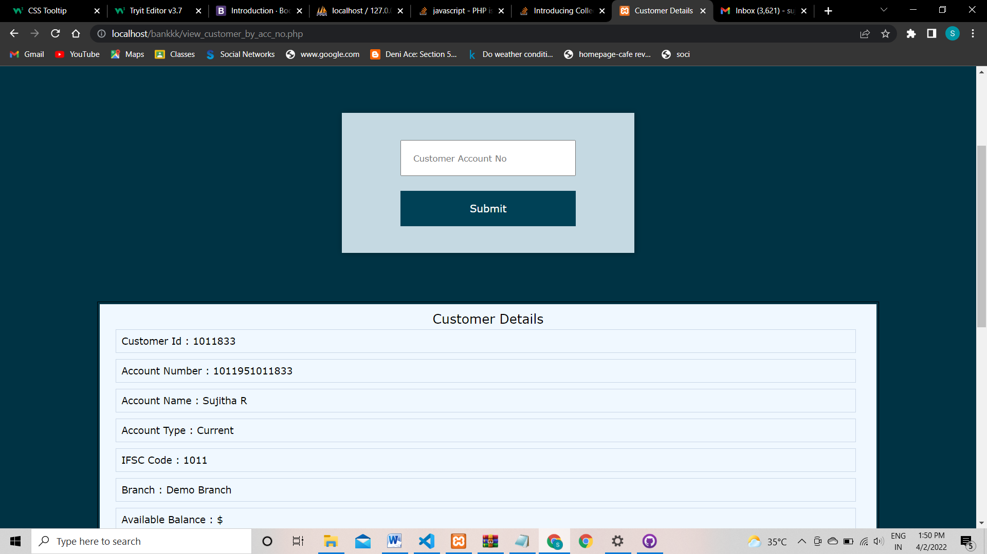

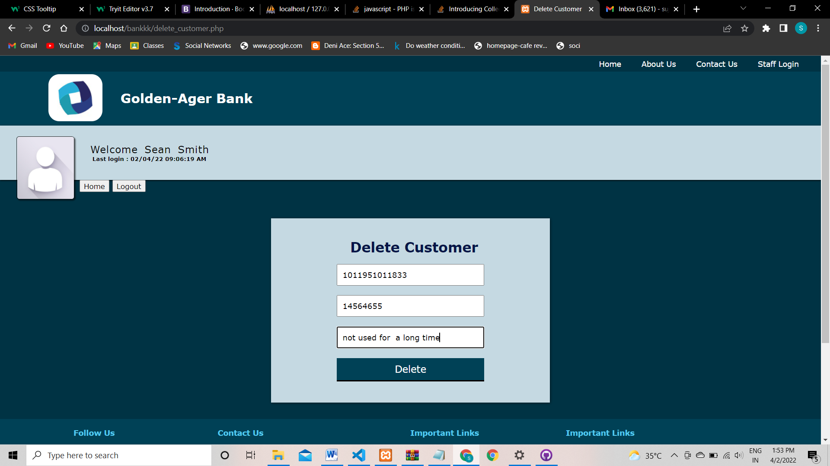

OTP:



